GROOMER SHED CONSTRUCTION JUNE 17, 2017
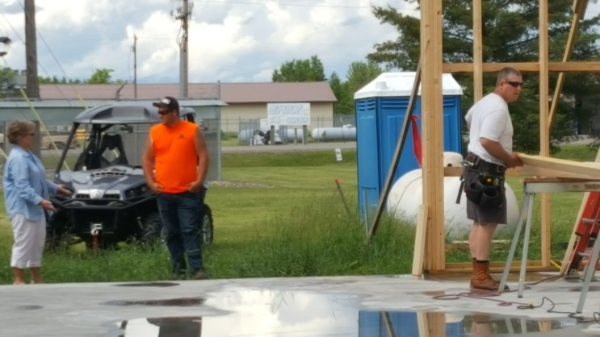 |  | 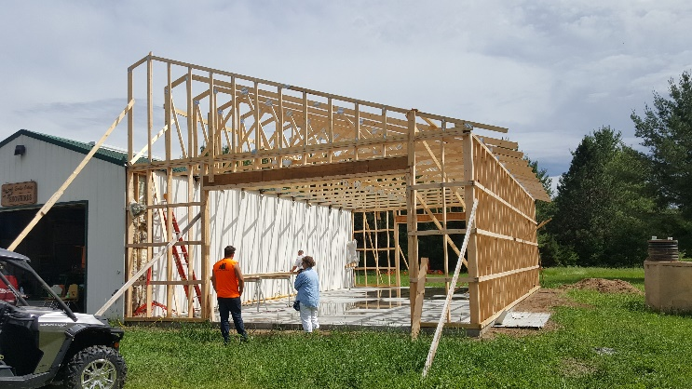
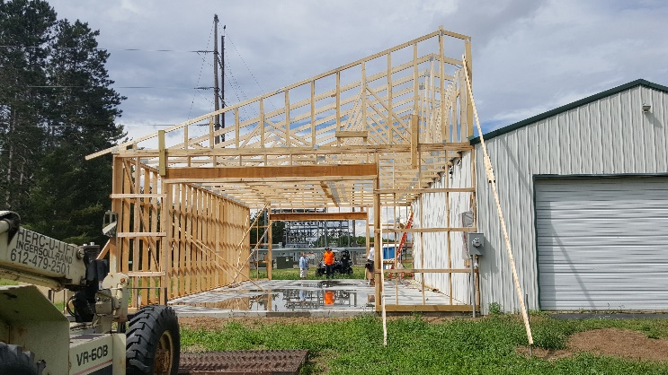 |  | 