GROOMER SHED CONSTRUCTION JUNE 2, 2017
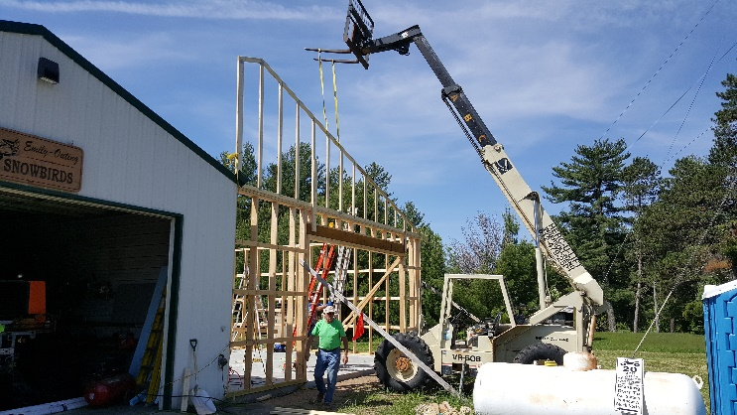 |  | 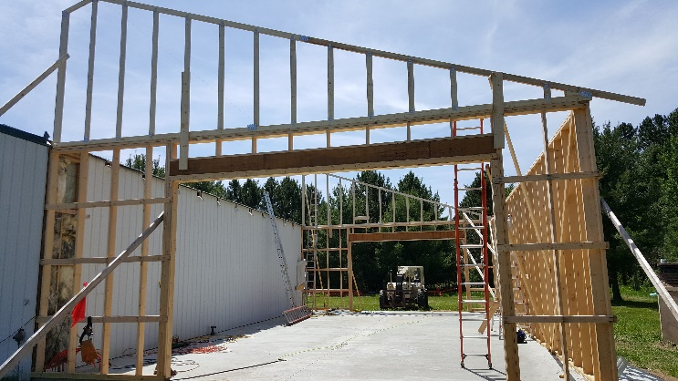
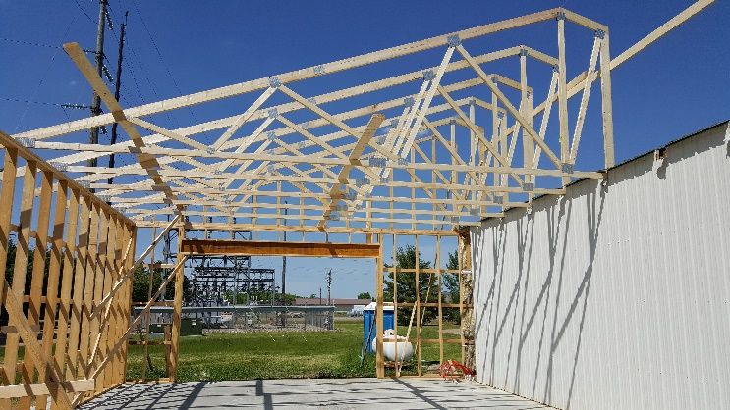 |  | 