GROOMER SHED CONSTRUCTION APRIL 8, 2017
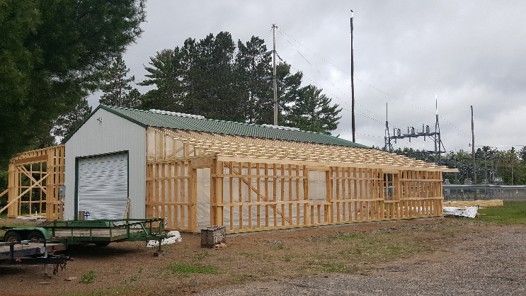 |  | 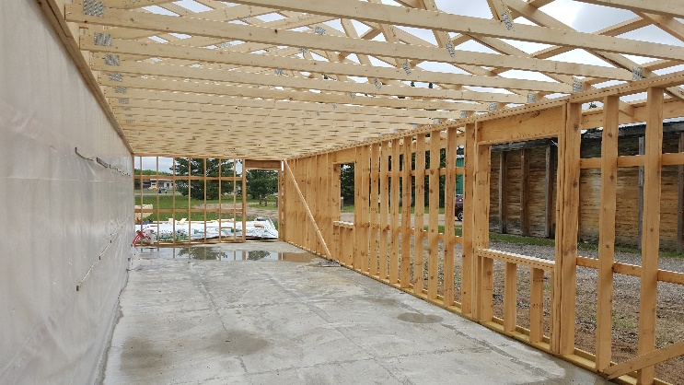
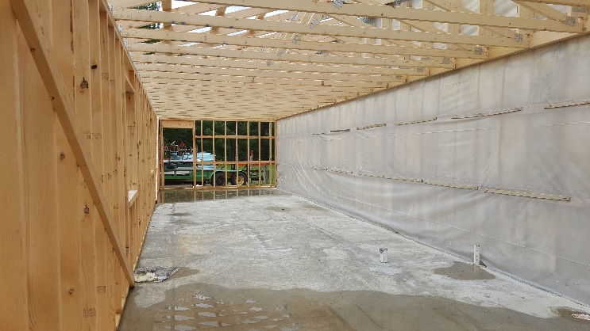 |  | 