GROOMER SHED CONSTRUCTION AUGUST 16, 2017
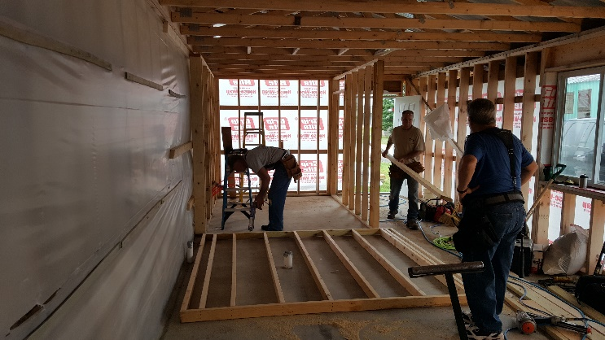 |  | 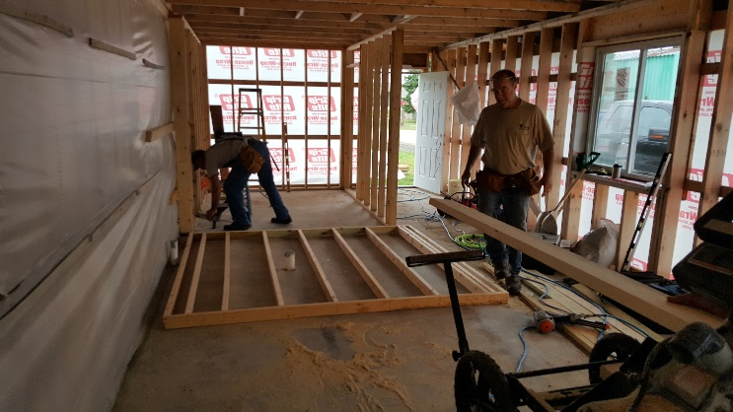
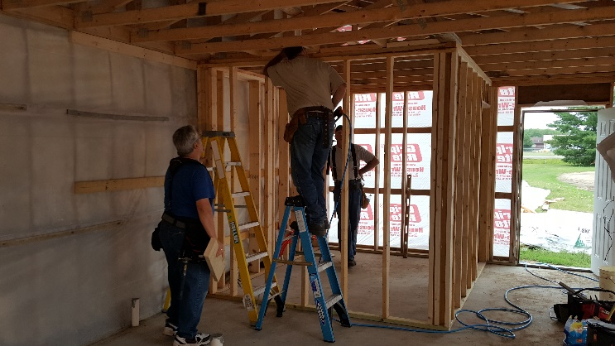 |  | 