GROOMER SHED CONSTRUCTION JULY 26, 2017
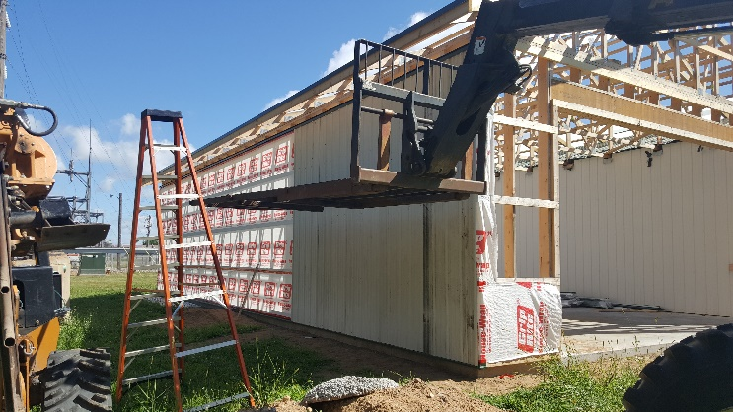 |  | 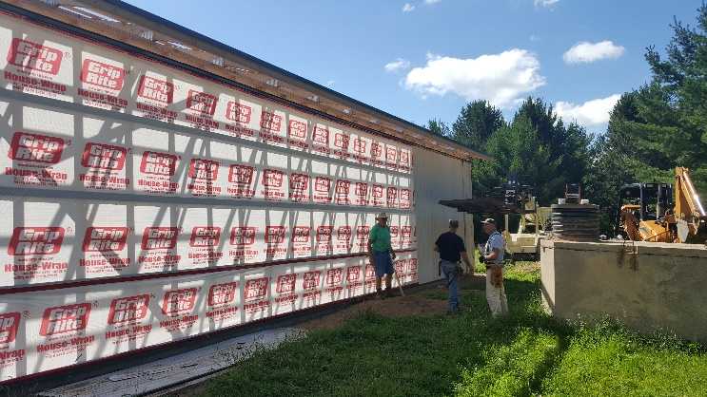
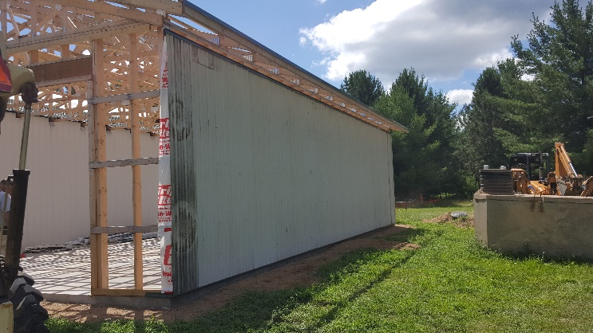 |  | 